FREQUENCY DISTRIBUTION
GPA | No. of students
1.5 – 2.00  2.01 – 2.50  2.51 – 3.00  3.01 – 3.50  3.51 – 4.00 | 5  6  8  2  1

X | No. of patient | P = f/N | % of Proportion
KPK  Sindh  Punjab | 401  990  1300 | 401/2691 =0.1490  990/2691 = 0.3678  1300/2691 = 0.4830 | 0.1490*100 = 14.90  0.3678*100 = 36.78  0.4830*100 = 48.30
 | N = 2691 | Total = 1 | Total = 100

- 2.5, 3.6, 2.4, 4, 3.6(Ungrouped data without frequency)
GPA | F
2.00  2.50  3.00  3.50  4.00 | 7  10  4  6  .  2
STEPS FOR CONSTRUCTION OF FREQUENCY DISTRIBUTION:
Step01) Stem and Leaf Method: it is used to arrange the data in ascending and descending form.
Step02) find the Range as:
Range = Max: -Min:
Step03) No. of Classes:
K = 1 + 3.3logN N: Total Number of observation
Step04) Class Interval: h = $\frac{Range}{K}$
Step01) Stem and Leaf Arrangement method:
Stem | Leaf | Leaf Array
3 | 3,2 | 2,3
4 | 6,2 | 2,6
5 | 6,2,9,7 | 2,6,7,9
6 | 8,2,3 | 2,3,8
7 | 1,6,4,3,8,4,6 | 1,3,4,4,6,6,8
8 | 3,5,2,1 | 1,2,3,5
9 | 7,3 | 3,7

32, 33, 42, 46, 52, 56, 57, 59, 62, 63, 68, 71, 73, 74, 74, 76, 76, 78, 81, 82, 83, 85, 93, 97
Here Min: = 32 & Max: = 97 8(Stem) 2(Leaf) 3(stem) 2(Leaf)

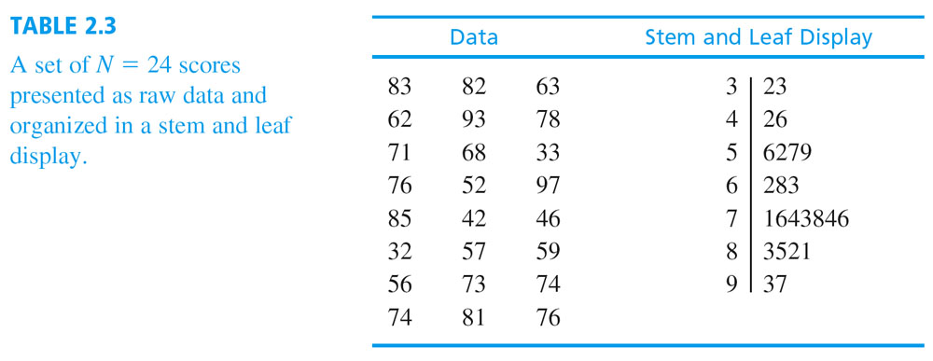
Step02) To find Range:
Range = Max: - Min:
Range =97 – 32
Range = 65
Step03) No. of Classes:
K = 1 + 3.3logN Here N= 24
K = 1 + 3.3log(24)
K = 1 + 3.3(1.3802)
K= 1 +4.5546
K = 5.5546 (Round off 5.5546 approximately = 6
K = 6
Step04) Class interval:
h = $\frac{Range}{K}$
h = 65/6 =10.83 (10.83 =11) /(10.16 = 11) OR (10.14 = 10)
h = 11 (43 - 42)/2 = ½ = 0.5
[Ascending form of data is 32, 33, 42, 46, 52, 56, 57, 59, 62, 63, 68, 71, 73, 74, 74, 76, 76, 78, 81, 82, 83, 85, 93, 97]
Here Min:= 32 , Max: = 97 , K = 6 & h = 11
Frequency Distribution
Data | Tally Bar | f | Class Boundaries | Mid Point(X)
32 – 42  43 – 53  54 – 64  65 – 75  76 – 86  87 – 97 |  | 3  2  5  5  7  2 | 31.5 – 42.5  42.5 – 53.5  53.5 – 64.5  64.5 – 75.5  75.5 – 86.5  86.5 – 97.5 | (31.5+42.5)/2 = 37  (42.5+53.5)/2 = 48  59  70  81  92
 |  | N = 24

7- 81 Polygon
6-
5- 59 70 Histogram
Frequency 4-
3- 37
2- 48 92
1-
31.5 42.5 53.5 64.5 75.5 86.5 97.5 Class Boundaries

